**UMGC Property Rentals**

**User Interface Design Document**

**SWEN 651 9040 Usability Engineering**

Version: 1.0

Prepared for: Professor Nicolae Tapus

Prepared by: Alireza Minagar

Date: October 29, 2024

Table of Contents

1. INTRODUCTION
   * 1.1 Purpose
   * 1.2 Scope
   * 1.3 Reference Document
   * 1.4 Terms, Abbreviations, and Acronyms
2. GRAPHICAL INTERFACE DESIGN
   * 2.1 Desktop UI Screens
     + 2.1.1 Home Screen
     + 2.1.2 Property Details
     + 2.1.3 Sign Up / Sign In Screen
   * 2.2 Mobile UI Screens
     + 2.2.1 Home Screen
     + 2.2.2 Property Details
   * 2.3 Tablet UI Screens
     + 2.3.1 Home Screen
3. Conclusion

**1. INTRODUCTION**

**1.1 Purpose**

The purpose of this document is to provide a detailed outline of the user interface (UI) design for the "UMGC Property Rentals" application. This application has been developed to simplify and enhance the process of renting properties by offering an intuitive and visually appealing interface accessible across various devices, including desktop, mobile, and tablet platforms. By designing with cross-platform compatibility in mind, the application seeks to provide users with a seamless experience, ensuring consistent functionality and design elements across different screen sizes and operating systems (Tidwell, 2011). The UIs for various platforms have been designed using Figma.

The user interface design outlined in this document aims to achieve three primary objectives:

1. **User-Friendly Navigation**: To ensure that potential tenants can easily search, view, and inquire about available properties, providing a streamlined experience from browsing listings to contacting property managers (Krug, 2014).
2. **Comprehensive Property Display**: Each listing presents essential information, including location, property features, rent price, and images, making it easier for users to compare and decide on suitable properties (Garrett, 2011).
3. **Enhanced Accessibility and Responsiveness**: The UI is optimized for both mobile and desktop usage, allowing users to access the application on-the-go via mobile devices or at home on larger screens (Morville & Rosenfeld, 2006).

This document will serve as a foundational resource for developers, designers, and stakeholders involved in the application development, offering insights into the layout, functionality, and visual elements of each screen. Furthermore, it sets a standard for consistency and usability, ensuring that each user interaction is meaningful, efficient, and visually cohesive across all devices.

**1.2 Scope**

This document covers the primary modules of the UMGC Property Rentals application, focusing on the home screen, property details, and account management (Sign Up/Sign In). Each screen has been designed to optimize the user experience for both functionality and aesthetics.

**1.3 Reference Document**

* Project requirements document
* Style guide for UMGC branding

**1.4 Terms, Abbreviations, and Acronyms**

* **UI**: User Interface
* **UX**: User Experience

**2. GRAPHICAL INTERFACE DESIGN**

**2.1 Desktop UI Screens**

**2.1.1 Home Screen**

* **Screen Name**: Home Screen for desktop version is presented below:

Figure 1. Desktop Home Screen for UMGC Property Rentals

This figure shows the **Home screen for the UMGC Property Rentals desktop application**, designed for a screen resolution of **1440 x 1024 pixels**. The layout features a central banner welcoming users with the application name and tagline, "Where you find your dream house," set on a blue background to ensure visibility.

The home screen for the UMGC Property Rentals desktop version, optimized for a 1440 x 1024 resolution, features a prominent banner with the application name and tagline, setting a welcoming tone (Cooper, Reimann, & Cronin, 2007).

Key elements include:

1. **Property Cards**: Displayed below the banner, each card presents:
   * Location, square footage, bedroom/bathroom count, amenities, and monthly rent.
   * A heart icon to save favorite properties, enhancing user engagement.
2. **Call-to-Action Buttons**: Centrally positioned "Sign Up" and "Sign In" buttons for account actions, plus "New Listing," "Available," and "Price Drop" options for property filtering.
3. **Notification Icon**: A bell icon alerts users to updates, positioned in the top right for easy access (Norman, 2013).
4. **Call-to-Action Buttons**:
   * **Sign Up** and **Sign In**: Positioned centrally below the property listings, these buttons provide quick access to user account actions.
   * **Filter Options**: Located at the bottom left, labeled as "New Listing," "Available," and "Price Drop," these buttons allow users to refine the displayed properties based on their preferences.
5. **Notification Icon**: Positioned on the top right side of the screen, the bell icon alerts users to new messages or updates regarding property listings.

The design offers a clear and visually organized presentation of key information, prioritizing ease of navigation and accessibility for users interested in finding or saving rental properties.

A more refined image is presented in Figure 2:

Figure 2. A more refined image of the home screen for the desktop version.

* **Internal UI functionality**: Displays property listings with quick access buttons like "New Listing," "Available," and "Price Drop." Users can scroll through properties and click on each to view more details.
* **External UI functionality**: Links to "Sign Up" and "Sign In" screens for user account management.

**2.1.2 Property Details**

* **Screen Name**: Property Details

Once the user signs in and clicks on any of the presented properties on the home screen, the image below appears (Figure 3).

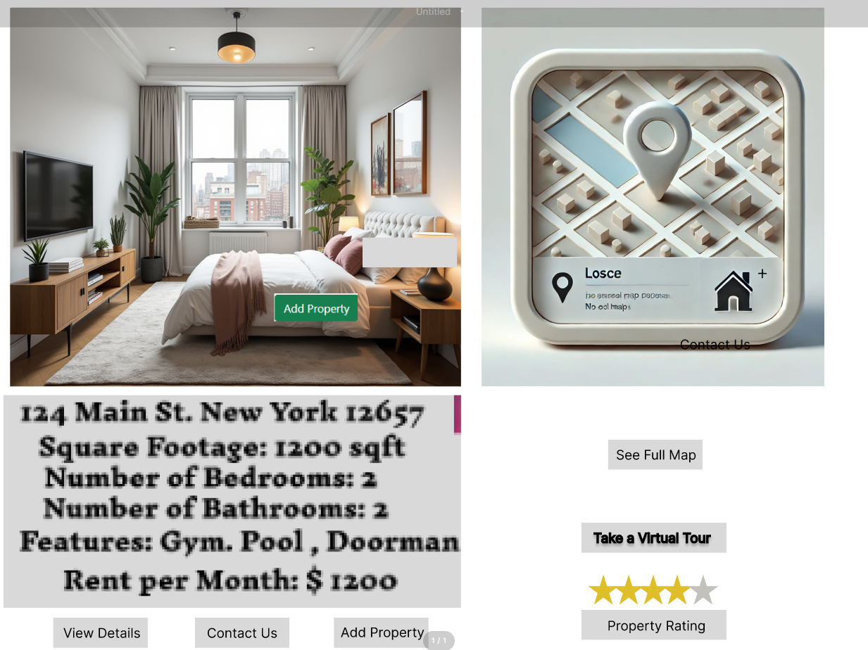

Figure 3 represents a detailed property listing interface for the "UMGC Property Rentals" application. It is organized to provide a rich visual and informational overview of a specific rental property. The layout includes:

1. **Property Image**: On the left side of the screen, a high-resolution image showcases the interior of the property to give users a realistic view of the living space.
2. **Property Details**: Directly below the image, property details such as the address, square footage, number of bedrooms and bathrooms, and unique features (e.g., gym, pool, doorman) are listed. This provides all essential property information briefly.
3. **Interactive Buttons**:
   * **View Details** and **Contact Us** buttons are included to allow users to view additional property information or directly reach out for inquiries.
   * **Add Property**: This button allows users to bookmark or add the property to their favorites list.
4. **Mini-Map View**: On the right, a stylized map section features a simple mock map for visualizing the property's location. This can help users understand the general neighborhood layout.
5. **Virtual Tour and Rating**:
   * A button to "Take a Virtual Tour" is included, allowing potential renters to explore the property digitally.
   * A **Property Rating** section with stars allows users to see how the property has been rated by other users.

This layout provides an interactive, user-friendly experience designed to enhance engagement and help users make informed decisions about rental properties.

* **Internal UI functionality**: Shows detailed information about each property, including square footage, bedroom and bathroom count, amenities, and rental price.
* **External UI functionality**: Includes buttons for "View Details," "Contact Us," "See Full Map," and "Take a Virtual Tour."

**2.1.3 Sign Up / Sign In Screen**

* **Screen Name**: Account Management

Below the “Create Account” page is presented. This page appears once the user attempts to sign up (Figure 4).

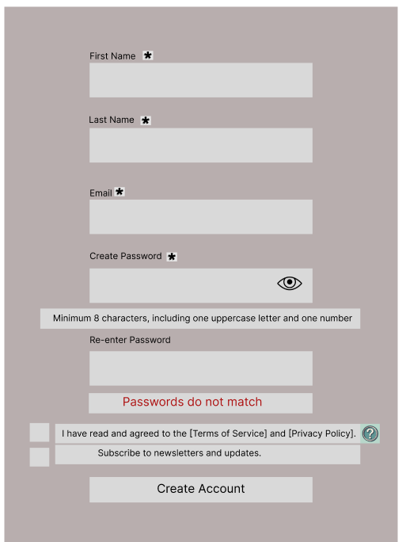

Figure 4 depicts the "Create Account" interface for the UMGC Property Rental application. Users are prompted to fill in their personal information, including *First Name*, *Last Name*, *Email*, and *Password*, with required fields marked by an asterisk (*). Below the password field, a password-strength requirement is displayed, specifying the need for at least 8 characters, including an uppercase letter and a number.

A "Passwords do not match" error message is shown under the *Re-enter Password* field, which will appear if the password fields are inconsistent.

At the bottom, two optional checkboxes are available:

1. Agreement to the [Terms of Service] and [Privacy Policy], with a help icon providing additional details.
2. Option to subscribe to newsletters and updates.

The interface concludes with a prominent *Create Account* button, guiding users to complete the sign-up process. This clean, minimalist design ensures a user-friendly experience by clearly marking required fields and providing visual feedback for any entry errors.

Next, once an existing client signs into his/her account the page below appears (Figure 5).

Figure 5illustrates the *Sign-In Page* for the "UMGC Property Rentals" application, designed to allow returning users to log into their accounts. The interface is organized to prioritize user convenience and accessibility:

* **Page Title**: At the top of the page, a banner displays a welcoming message, "Welcome to UMGC Property Rentals," indicating the app's purpose.
* **Email and Password Fields**: Below the title, two input fields labeled *Email* and *Password* are provided for users to enter their credentials. The password field includes an "eye" icon, allowing users to toggle the visibility of their password for easier input.
* **Remember Me Checkbox**: A checkbox labeled "Remember me" provides users with the option to stay signed in on the device, which enhances convenience for frequent users.
* **Forgot Username or Password Link**: This link, positioned below the password field, allows users to recover their credentials in case they forget them, improving accessibility and user support.
* **Sign-In Button**: The primary *Sign-In* button is centrally positioned to encourage users to log in after filling in their credentials.
* **Social Media Login Options**: Below the standard sign-in button, users have an option to "Sign in with your social media account" via icons for Facebook and Instagram. This feature provides a quicker alternative for users who prefer logging in with their social media profiles.
* The overall design emphasizes simplicity, with light pink fields and a grey background that provide a calm, professional aesthetic, promoting ease of use for users across different devices. This screen supports essential login functionalities while offering quick recovery and alternative login options.
* **Internal UI functionality**: Contains form fields for "First Name," "Last Name," "Email," "Create Password," and "Re-enter Password." Includes password requirements and a "Create Account" button.
* **External UI functionality**: Redirects to the home screen after successful sign-up or sign-in (Figure 5).

**2.2 Mobile UI Screens**

**2.2.1 Home Screen**

* **Screen Name**: Mobile Home Screen (Figure 6)

Figure 6 displays the mobile-optimized user interface for the UMGC Property Rentals application, designed for easy navigation and accessibility on smaller screens. The interface includes the following key elements:

1. **Header Section**: A welcoming banner at the top, reading "Welcome to UMGC Property Rentals – Where You Find Your Dream House," establishes the app's purpose and sets a friendly tone.
2. **Property Listings**: Each property is displayed with essential details, including address, square footage, number of bedrooms, bathrooms, notable features (e.g., gym, garage), and monthly rent. The listings are arranged vertically for easy scrolling on mobile devices (Nielsen, 2013).
3. **Action Buttons**:
   * **Create Account** and **Sign In** buttons are centrally positioned below the property listings, providing easy access for new users to register or for existing users to log in.
   * **Interactive Navigation Buttons** at the bottom, labeled "New Listing," "Available," and "Price Drop," allow users to filter properties based on these categories, enhancing the browsing experience.
4. **Notification Icon**: Located in the top right corner, a notification bell icon is available to inform users of updates, alerts, or new messages regarding property listings.

The design emphasizes clarity, ease of navigation, and quick access to property details, all tailored to fit comfortably within the constraints of a mobile screen for optimal usability.

* **Internal UI functionality**: Optimized for mobile, displaying a scrollable list of properties with essential details and images.
* **External UI functionality**: Accessible navigation for "Sign Up," "Sign In," and property details.

**2.2.2 Property Details**

* **Screen Name**: Mobile Property Details

Once the user explores the advertised properties, for each property, a page as presented below with more information appears (Figures 6 and 7).

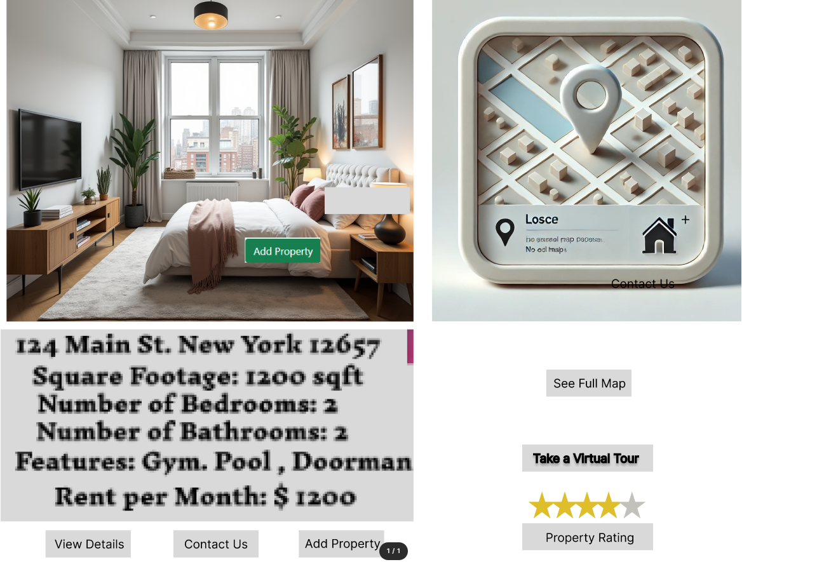

Figure 6

Figure 7

Figures 6 and 7 demonstrate two key screens for property information. The layout offers users both an interior view of the property and a simplified map showing the property's general location.

* **Property Information Section**:
* The left panel displays an image of the property’s interior, including essential details like address, square footage, and room configuration. Key features are highlighted, such as gym access, pool availability, and doorman service, with the monthly rent specified.
* Below the main property description are interactive buttons like "View Details," "Contact Us," and "Add Property," allowing users to quickly access more information, reach out, or save the property.
* **Map and Interaction Panel**:
* The right panel contains a simplified map labeled "Losce" (an arbitrary name for illustration), providing an overview of the property's vicinity. Users can explore more through the “See Full Map” button.
* Additional options include "Take a Virtual Tour" and a star rating system under “Property Rating,” which provides user feedback on the property.
* This interface design is created for easy access to vital property information while offering engaging, interactive features to enhance user experience. The screen resolution is 1440 x 1024, ensuring a crisp display on desktop monitors.
* **Internal UI functionality**: Displays property information with a condensed layout suitable for mobile screens.
* **External UI functionality**: "Contact Us" and "View Full Map" links for more user actions.

**2.3 Tablet UI Screens**

**2.3.1 Home Screen**

* **Screen Name**: Tablet Home Screen (Figure 8)

Figure 8 demonstrates the main desktop interface for the "UMGC Property Rentals" application. The interface features a welcoming header that reads "Welcome to UMGC Property Rentals," followed by a tagline, "Where you find your dream house," which highlights the purpose of the platform.

Below the header, three property listings are displayed with images, location details, square footage, the number of bedrooms and bathrooms, notable features, and rental prices. Each property includes a heart icon, suggesting a "favorites" feature for users to mark properties of interest (Cooper, Reimann, & Cronin, 2007).

At the bottom of the screen, three action buttons—"New Listing," "Available," and "Price Drop"—allow users to filter or browse different categories of properties. Additionally, large "Sign Up" and "Sign In" buttons provide easy access for user account management, streamlining the onboarding process. The clean and organized layout ensures a user-friendly experience (Norman, 2013).

* **Internal UI functionality**: Presents property listings in a two-column grid, balancing space and information for tablet dimensions.
* **External UI functionality**: Provides smooth navigation to property details and user account actions.

A view of the “Create Account” page for the new clients

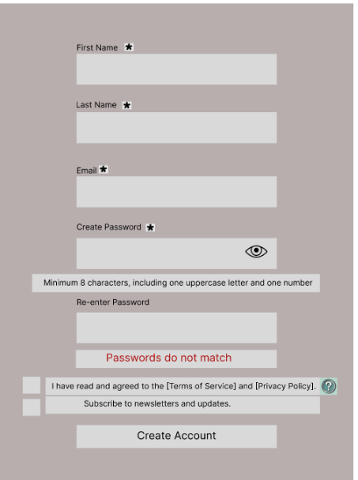

Figure 4, as described earlier, demonstrate the sign up and create account page.

The account creation page prompts users for personal information, adhering to UI principles for ease and error prevention:

1. **Error Feedback**: A “Passwords do not match” message provides immediate input feedback (Shneiderman & Plaisant, 2010).
2. **Checkbox Options**: Terms agreement and newsletter subscription checkboxes ensure compliance and engagement.

**Additional Notes**

1. **Map Section**: The "See Full Map" and "Contact Us" options have been added to enhance location visibility and user engagement.
2. **User Ratings**: A "Property Rating" section provides user feedback and builds trust in property listings.
3. **Tablet Version**: Consider adding a tablet-specific screen layout for each primary section to ensure a consistent user experience across devices.

This structure provides a clear, professional document that describes each UI component in detail. Once you add screenshots for each UI component, this document will be ready to present the project. Let me know if you need help creating the tablet UI layout!

1. **Conclusion**

The UMGC Property Rentals UI design document provides a structured and thorough approach to creating a user-centered rental application, balancing ease of navigation, detailed property display, and accessibility. This document highlights essential screens for desktop, mobile, and tablet, emphasizing an engaging, seamless user experience across all platforms. By following best practices in UI/UX design and ensuring that every interaction is purposeful, the UMGC Property Rentals application is poised to offer an efficient and enjoyable property rental process. This document serves as a foundational guide for the development team to maintain visual coherence and usability standards across devices, fostering user satisfaction and engagement in the rental market.

**References**

* Cooper, A., Reimann, R., & Cronin, D. (2007). *About Face 3: The Essentials of Interaction Design*. Wiley.
* Garrett, J. J. (2011). *The Elements of User Experience: User-Centered Design for the Web and Beyond*. Pearson Education.
* Krug, S. (2014). *Don't Make Me Think, Revisited: A Common Sense Approach to Web Usability*. New Riders.
* Morville, P., & Rosenfeld, L. (2006). *Information Architecture for the World Wide Web: Designing Large-Scale Web Sites*. O'Reilly Media.
* Nielsen, J., & Budiu, R. (2013). *Mobile Usability*. New Riders.
* Norman, D. A. (2013). *The Design of Everyday Things: Revised and Expanded Edition*. Basic Books.
* Shneiderman, B., & Plaisant, C. (2010). *Designing the User Interface: Strategies for Effective Human-Computer Interaction*. Pearson.
* Tidwell, J. (2011). *Designing Interfaces: Patterns for Effective Interaction Design*. O'Reilly Media.